**CME 2201 - Assignment 2**

**JOURNEY PLANNER FOR PARIS METRO**

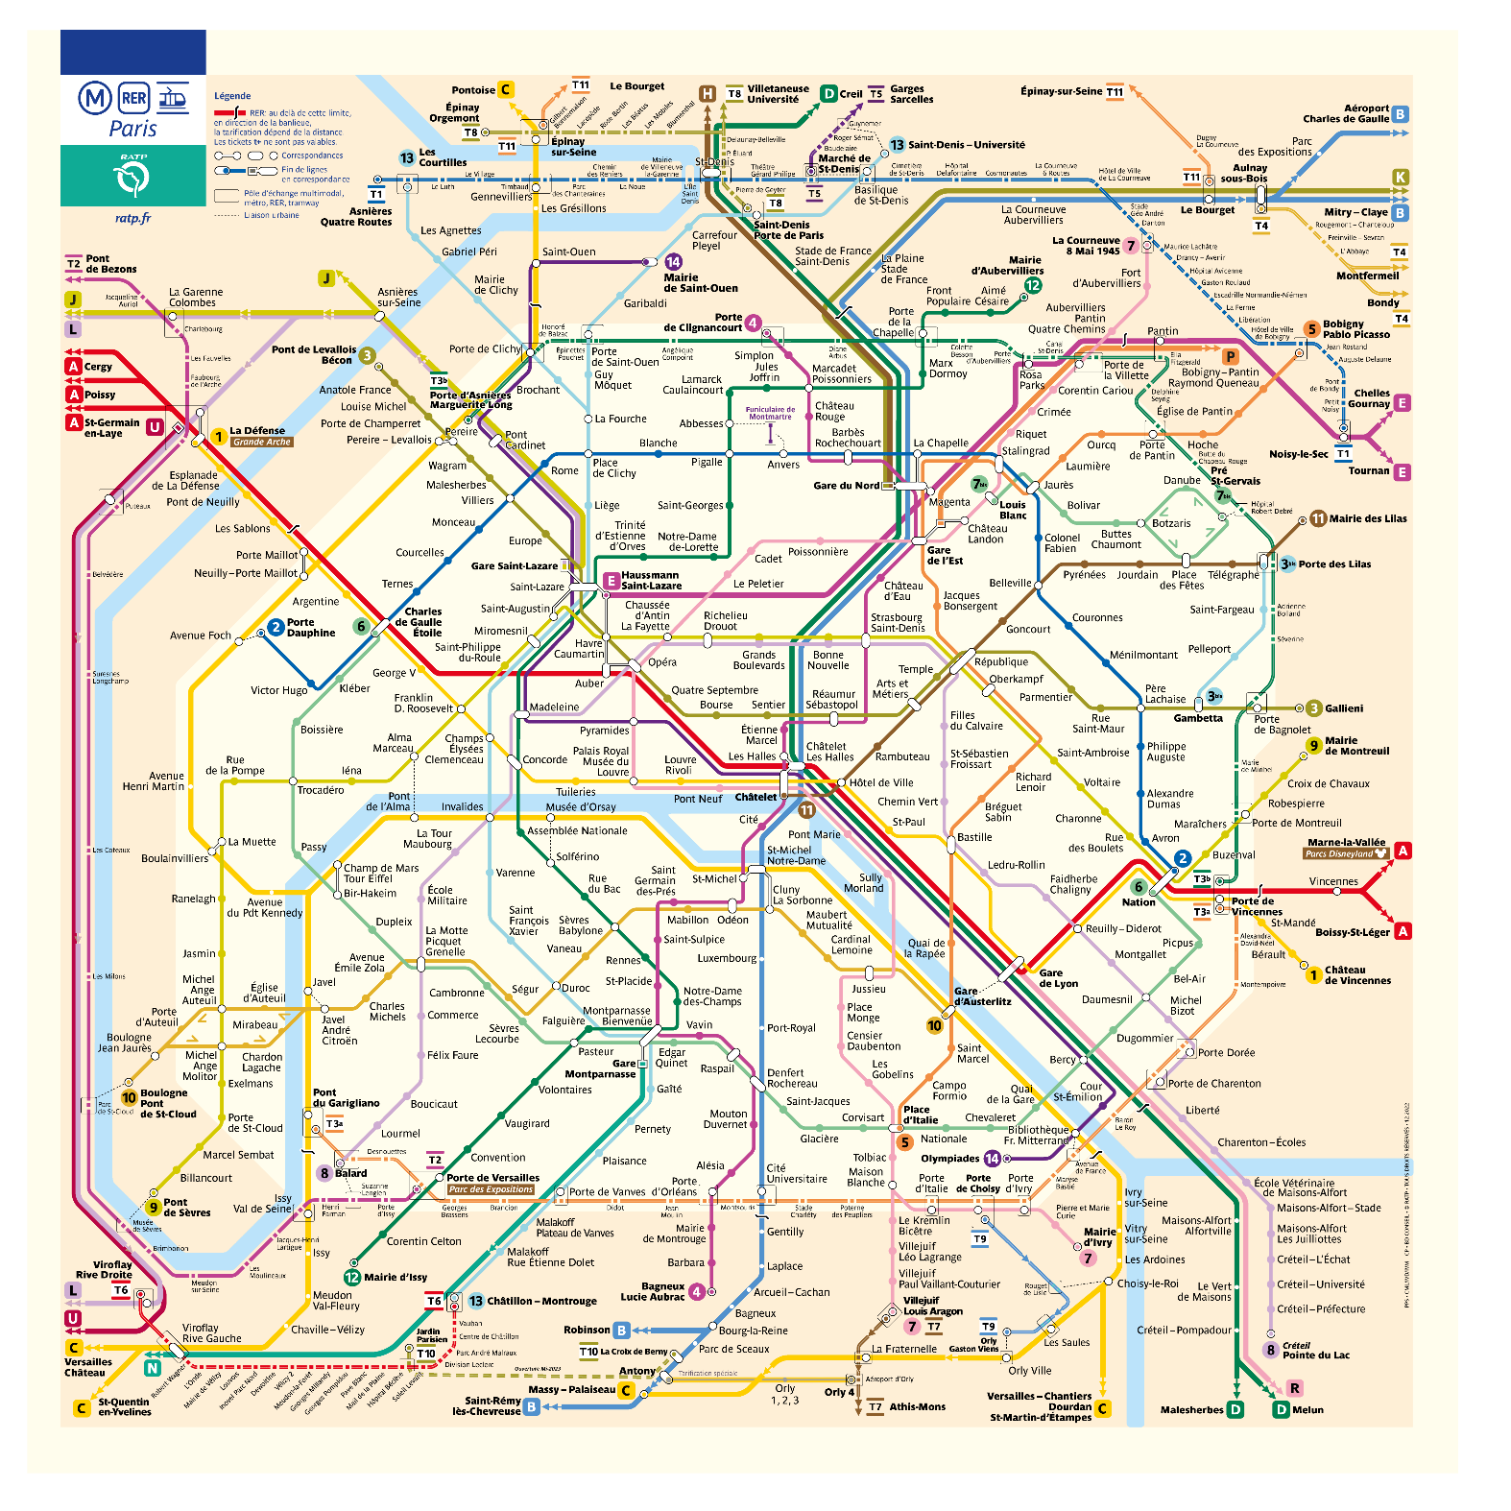

Paris Metro is the [second busiest metro system](https://en.wikipedia.org/wiki/List_of_metro_systems) in [Europe](https://en.wikipedia.org/wiki/Europe), after the [Moscow Metro](https://en.wikipedia.org/wiki/Moscow_Metro), as well as the tenth-busiest in the world [1]. It carried 1.498 billion passengers in 2019, roughly 4.1 million passengers a day, which makes it the most used public transport system in Paris [2].  As of the end of May 2022, there are a total of 308 stations on 16 different lines [3].

A journey planner (or trip planner) is a specialized electronic search engine that finds one or more journey (trip) suggestions between an origin and a destination. This system assists travelers in planning their journey.

1. **Journey Planner Search Engine**

In this assignment, you are expected to develop an algorithm to find the best journey between the given ***origin*** and ***destination*** stops. You should consider two optimization criteria: ***fewer stops*** and ***minimum time***. In the first case, you should use equal edge weights in the graph. In the second case, you should use the given time intervals in the consecutive stops. You should represent each metro station as a node and represent each line connecting two consecutive stops in a certain direction as a directed edge to form a transportation graph. This graph is a directed graph as illustrated in Figure 1.

Figure 1. Illustration of a transportation graph.

To make point to point queries in a transportation network, some sort of walk(transfer) edges are required, so any stage of the journey can be covered by walk or passengers may walk between the stops while transferring between two different lines. Walk-distance edges are also providing to link each of the transportation networks (bus, train, metro, ferry etc.). Two stops u and v are labeled as neighbor stops by adding walk-distance edges between them, if a road segment is available to pedestrians and $dist\left(u, v\right)$ $i$ s less than the maximum allowed walking distance.

A sample query from the origin station “Charles de Gaulle” to destination station “Odéon” returns following result.

|  |
| --- |
| Origin station: Charles de Gaulle  Destination station: Odéon  Preferetion: Minimum Time  Suggestion  Line 1:  Charles de Gaulle-Etoile – Châtelet (8 stations)  Line 4  Châtelet – Odéon (3 stations)  21 min |

1. **Bonus**
2. **Limiting the transfers**

You should modify your algorithm to limit transfers. Thus, the alternative paths include only direct routes and the routes containing up to two transfers. Two consecutive walks are not allowed.

1. **Suggesting more than one alternative**

You should modify your algorithm to suggest more than one alternative (best paths up to five). Several runs of the algorithm are required to find alternative paths.

1. **Testing and Reporting**

You should test your algorithm with the given origin-destination stop list. Report the average query time in your project report. In addition, explain the details of your algorithm. Your report should contain a cover page specifying the group members.

1. **Provided Resources**

* Paris_RER_Metro.csv (Contains all metro lines and A and B RER lines)
* Test query file (will be provided later)

1. **Project Groups**

You can develop the project individually or create a group of up to two students. If there has been any change in your group, please update it in the file below.

[PROJECT GROUPS](https://docs.google.com/spreadsheets/d/18sRZAeLgMvT0X99y38gLoYOrfvXVnW209Bjj5pbb4YI/edit?usp=sharing)

1. **Due date**

**04.01.2024 Thursday 23:55**. Late submissions are not allowed. The due date will not be extended.

1. **Requirements**

* Usage of *Java* programming language and *Edge List Graph Data Structure* are required.
* *Object Oriented Programming (OOP)* principles must be applied.
* *Exception handling* must be used when it is needed.

1. **Submission**

You must upload your all ‘.java’ files and report as an archive file (.zip or .rar). Your archived file should be named as ‘studentnumber_name_surname.rar.zip’ (e.g., 2007510011_Ali_Yılmaz.rar or 2007510011_Ali_Yılmaz_2007510012_Aras_Aydin.rar) and should be uploaded via **online.deu.edu.tr**.

1. **Code Control**

Control of the project will be on 05.01.2024 in laboratory sessions. A schedule will be announced before the code control date. You must be in the laboratory on time. You will have 10 minutes to show your assignment. Please do not forget to bring your laptops while coming to the assignment control!

1. **Plagiarism Control**

The submissions will be checked for code similarity. Copy assignments will be graded as zero.

1. **Grading Policy**

|  |  |
| --- | --- |
| **Job** | **Percentage** |
| Usage of and Edge List Graph Data Structure, ADT, OOP and Try-Catch | %30 |
| Journey Planner Search Engine implementation | %50 |
| Execution of the Test Queries | %10 |
| Report | %10 |
| Bonus | Max. 20 points |

**References**

1. <https://www.ratp.fr/plan-metro>
2. <https://en.wikipedia.org/wiki/Paris_M%C3%A9tro>
3. <https://en.wikipedia.org/wiki/List_of_Paris_M%C3%A9tro_stations>
4. <https://prim.iledefrance-mobilites.fr/en/catalogue-data>